# Michael Chillemi

# 06/02/2023

# CS 590 - Algorithms

# M2.B3: Module 2 Basic Data Structures Application Exercises

Problem 2.5.23

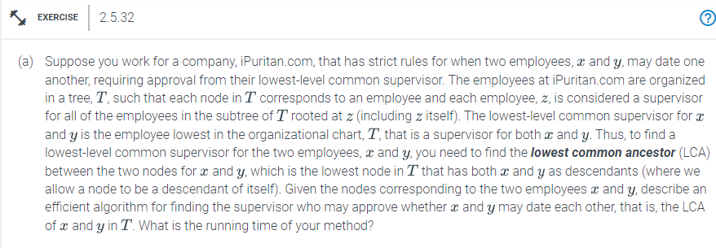

Answer:

Algorithm lowestCommonAncestor(Nodez, Nodex, Nodey):

Input: Nodez, Nodex, Nodey

Output: Reversed_Array

If Node is 0

return null

If Node is Nodex, Nodez is Nodey

return Nodez

Leftnode = lowestCommonAncestor(Nodez.left,Nodex,Nodey)

Rightnode = lowestCommonAncestor(Nodez.right,Nodex,Nodey)

If Leftnode and Rightnode

return Nodez

If Leftnode is true

return Leftnode

else

return Rightnode

The pseudocode mentioned above utilizes a breadth-first search to determine the diameter. The running time of this algorithm is $O(n)$.